2009:
With the beginning of the year Helena and Angel moved into the house in Jomås. Helena bought it in 2007 to have a farm with horses and nature around. She wanted to build up a stable life for Angel and herself.
When Helena bought the house there was no plan or speech of to build up houses beside her house.

2010:
In that year the neighbours started to build up a road house on the right side of Helenas property.
Pictures are existing.

2011:
In that year the neigbours on the right side of Helenas property started to build up their house with the illigal uprising of the road. (It can be proofed with pictures).

In that year the drinking water was polluted by the neighbours. Helena and Angel got sick. The water got septic because of illigal working activities o the neighbours. (Proof is to be found on 21 pages of judgement papers as a file on Helenas computer).
At 08.01.2012 Helena moved with Angel into a house in Evje just to have peace and fresh water. They were forced to do so because the komune Froland did not want to help and the neighbours did not want to fix what they have ruined. Helena has to pay the rent for that house and the loan for her house in Froland. Also for the electric.
See the link: http://www.nrk.no/sorlandet/_-far-ikke-hjelp-av-kommunen-1.8336926
Pictures are existing.

Note: On the 30.11.2011 the first headline of the newspaper „Frolendingen“ was dealing with the destiny of Helena and Angel.

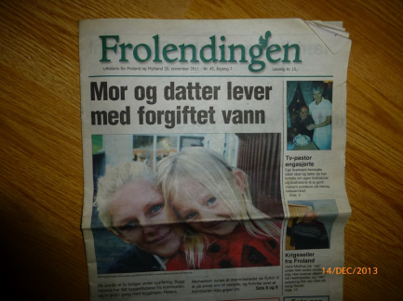

In July 2012 another headline story in „Frolendingen“ is dealing with the life of Helena and Angel.
In 2012 also NRK News on television is reporting about the circumstances of Helenas and Angels life.
At this time also the komune of Froland was interviewed – also by television before.

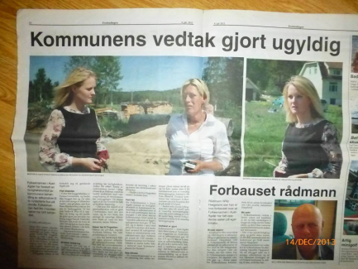

Examples for further newspaper reports:

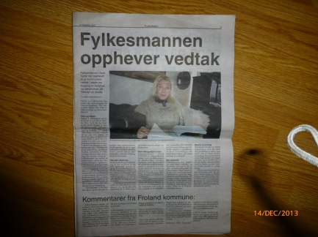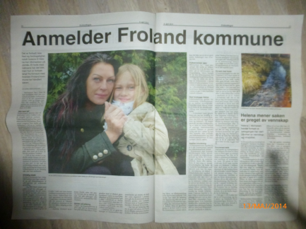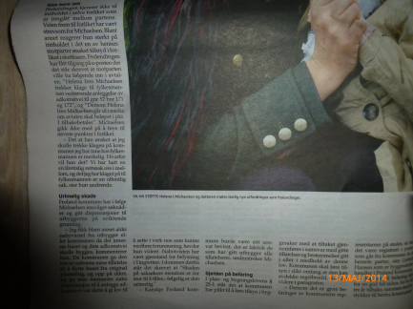

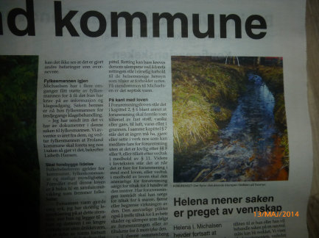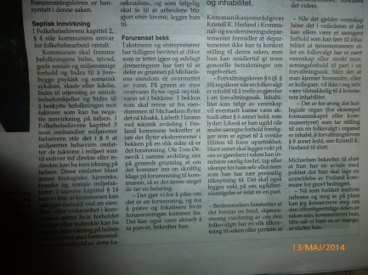
In 2012 Helena went to court and won over the neigbours. Helena should get about 500000 Norwegian Crowns from the neighbours to be able to built up her watersystem again and for lamyer cost. At least Helena accepted 100000 Norwegian Crowns because she got totally scared of the neigbours. Helena got no support from anybody. Even the police did not show up when Helena was calling them.
As Helena won the first court the neighbours did not accept and so they wanted to take the next level. The komune helped the neighbours because they send up komunal companies to bring wrong informations concerning the next court level (For example: „Agder Renovation“ changed their mind because they explained to Helena that they don‘t want to be involved in that case and drove away although it was very obvious for them to see what the neighbours have done).
Helena also won over the komune in Froland after a decision of the „Fylkesmannen“. In that decision the allowness of Froland komune concerning what the neighbours can do while the built up the house on the right side was unvalid. Helena won every case because it took several rounds.
At this time the rådmann of Froland komune named Willy HÆGELAND was astonished that the „Fylkesmannen“ took the case by his own initiative and he said that only a few out of hundreds of cases will be unvalid by the „Fylkesmannen“. (Newspaper „Frolendingen“)

Helena won three rounds towards Froland komune by the „Fylkesmannen“ (2014). The neigbours had to lower the drainage tube and to bring out the road further away from Helenas property until the 01.09.2014.
But befor the ending of that deadline they succeded by getting rid of Helena, Angel and their animals…
So far the neighbours did not obey that judgement and Froland komune can hide behind inhabilety.

Note: Extern papers of the court yard are exisiting

Note: Helena asked for kommune papers concerning the building case (These papers are existing). She discovered manipulated maps of of her area and the area of the neighbours. For example the place of the neighbours houses were fixed in the maps much further away from Helenas house then they are in reality. That also goes out to the water dike.
The man who gave the papers to Helena (Ole Tom ØRNEVIK – he was the vikar of Svein LAUVRAK) explained in a certain way that the papers are manipulated, if you find not all the themes inside which are standing on the list of contents.
Hans JOMÅS (member of the „Technical Etat“ in Froland komune – he lives in Froland) name was on one of the false maps. Helena confronted him with the false content oft he maps and he gave her a thread. He said, if Helena would put his name and the false maps on facebook it will be worse for her. He used a very special tone.
He used a company name on this maps he even did not work for (Company name is REPSTAD).

Summer 2011:
Witness: Roald Bredsten
In this summer happened a lot of intiminations by the neighbours (Aggression in verbal form or the lack on announcing the use of dynamite for their works (No neighbour warnings!!!). Helena, her daughter and the animals were frightened several times. The neighbours came to Helenas house and got very aggressive in discussions).
The neighbours placed a tent with three polish people who worked for them directly on the edge of Helenas property. She heard the polish people all the time and they were able to look into the livingroom of Helenas house. The neighbours said that the tent was standing at the best place of their
property.

2013:

Somewhere in 2013 Ove GUNDERSEN and also the neighbours made false facebook accounts after Helena blocked them. Obviously they wanted to follow Helenas account on the official track. (It is still possible to follow that tracks on facebook)

31.12.11-01.01.12
The neighbours having a party at the left side of Helenas property. With lights they went over to the house on the right side which was still in the building process. For one and half an hour they were shooting rockets towards the horses and the house of Helena. They were making fun of it and they were laughing about Helena. She called a friend (Roald Bredsten) who showed up aproximately about 01.30 h and he made photos of the firework garbage.
In between Helena called the police for help. A policeman said that police can not come. He gave the advice to record the scene with a mobile and take that as an evidence to the lokal police on the next working day.
Helena was scared and she shivered. Angel was with her father in Holland.
When Helena wanted to show that evidence than to the local police Ove Gundersen. He didnt wanted to see it and just said he had known that people in years and couldnt believe they had done that. He was agressiv on the phone. Helena did‘nt get any help and also no chance to show evidence.
31.12.13-01.01.14
The neighbours shoot again rockets against the horses and Helenas property. Angel was there this time and she got dead scared.
She ran into the house and HelenaI called the police again to get help again. Police did not have enough people to come for helping. So Helena recorded the incident and wanted to give that video (and pictures) tot he police later on. Thant he new local police Walther Lie.
It became a criminal charge but Helena denied to meet the neighbours at the „conflict råd“ and Helena just hoped for a different level of justice.
„But the file was closed due to the lack of evidences“. Evidences which have been accepted there before…

22.01.2014:

Helena was driving the Jomåsveien from the centrum back home. In between the dog pensionat and the entrance road to Helenas property Ken Rune Blankenberg drove with his car (Yellow van) near by Helenas car. And by pure will he destroyed the mirrior at the drivers door of Helenas car with his mirror. Without stopping and looking fort he demage he caused he drove further very fast.
Helena felt shocked and she stopped directly. She took a picture of the mirror damage and afterwards she called the local policeman Walter Lie. But she nearly could not explain what happened because she was crying so much. Helena told him who the driver was and mentioned what would have happened if Angel would have been also in the car. He only felt like leaving his office and check the lokal traffic circle if he could see the yellow van.
Afterwards he requsted the fotos of the damaged mirror and Helena sent them over to him. He talked to Ken Rune Blankenberg and he lied and said that Helena drove into his mirror. And than it didnt come out anything of that case either. So „they“ again got away with their crimes.

End of April 2014 / Beginning of May 2014:
In this period of time Helena and Angel got visitation from Jim WILKINSON, a man from Texas/USA. To dokument a few things he made photos of the property and the neighbours. Afterwards the police arrived at Helenas place and told Jim that the neighbours declared, he had been on their property to make pictures of their children in a naughty way. They said further on they had to take their children away. But the children have been still there. The policemen have been very rude so that also Angel got scared. They told Helena to move away. Jim has been to the local policeman Walter LIE for a two hour recording testamony about the case. Walter LIE knew the two policemen and mentioned that one of the policeman are known to be „an asshole to people“.
The testamony has never been given to Jim (like promised from Walter LIE) but it is still available at the police station in Arendal.

The day Jim appeared 7 of the neighbours showed up as a group. They were screaming, provoking and threatening. At this day they started to built up the high bushes which are still there.

Afterwards follows a down written report of Jim:

First I’d like to say, that everything Helena has told you in regards to things that happened at her place, to her, and to Angel, are the absolute truth. She has not told you any lies, and she is definitely not crazy. I made 2 trips to Norway at my own expense, because I know that she feared for her and Angels safety because of everything that was going on. If I myself didn’t believe her, do you think I would have done that? So again, I ask that you listen and believe what she says about everything that happened there.

Helena and I were on Skype on New Years Eve of 2013/2014 when the neighbors started shooting fireworks and rockets at the horses. I heard all of the noise in the background, and heard how upset both her, and Angel were. Prior to this happening, Helena and I spent many nights on Skype talking her case about how the neighbors treated both her and Angel. At first I could not believe that everything she said was actually happening. But the more we talked, the more I realized that these things were actually occurring. That New Years eve night certainly proved to me how crazy these people were. If they could do this to her horses, they certainly were capable of the treatment she and Angel received from them.

The first time I visited back in February of last year, I had a chance to sit with Helena, and go through all of the evidence that she had collected as to the damage done to her property by the neighbors. I believe that a large part of the reason these people treated her and Angel like they did, is that they were outsiders, and they were different than they were. As time went by, they found that Helena had no problems speaking the truth about everything, and that is something they did not like. She was bringing the truth to light, and they just did not like that fact. I also think that they wanted her land, since that area has many families that are related, and have been there for generations.

While I was there, the neighbors were pretty quiet, as my presence was made known to them. I was the long haired American, in the Black leather cowboy hat. So they pretty much left Helena alone. But, I did witness the treatment that Angel was being put through. Several times I saw the neighbor children walk down to a different bus stop, which left Angel by herself at the bus stop at the end of the driveway. I also was there when they started having an adult ride on the bus with Angel, to prevent the other kids from bullying her. I also was present when Helena and Angel talked about the things that they were doing to her on the bus, and at the school. Angel did not deserve any of that treatment. The only reason this was happening was that it was a way for the parents to get back at Helena. To get back at her because she wanted her property fixed, that they damaged when their house was being built.

Another thing I saw with my own eyes, was that anytime Helena would make a post on facebook, in regards to her court case against the neighbors, about the damage they had done to her property, about the way they treated her and Angel, there would be a lot of traffic going back and forth between the neighbors house on the right, and the house on the left of Helena’s place. So it was obvious that they were spying on her facebook page, watching anything and everything that she posted.

The second time I was there, at the end of April, first week of May, the neighbors were again aware of my presence there. But this time, they did not hide or stay out of sight, and tried to intimidate both Helena and I. They failed to intimidate me, but they sure tried their best. The weekend that they were putting in the tall hedge plants on their property line, we could hear them, making loud rude comments about Helena while we sat in chairs by the horse stable. At that point we both started laughing out loud at them. They became pretty quiet at that point. But anytime I would be outside, they would try to intimidate me by staring at me. But I would just stare right back at them. I would sit outside with my camera taking pictures, and they were not happy with that.

They were so unhappy with that, that they called the police in Arendal and filed false charges against me. They said I was reported to have been on the neighbor’s property taking pictures of their children. I have not, and will never photograph children, unless I’m being paid, or asked to take their photographs. I do have ethics when it comes to that kind of thing. They even stated that they had to send their children away. Both claims were an absolute lie! As the kids were still there the whole time I was at Helena’s. The two police officers that came out were rude and intimidating. They made comments about the stuff laying around the property. That it was unhealthy for Angel. They even suggested that Helena move. They also threatened to arrest me if I did not stop taking pictures. It’s strange, that over 3 years time, Helena made multiple calls and requests of the police for help, and they would do nothing. But when I was there, the minute the neighbors complained, and filed false charges, they show up.

It was at this time that Helena was trying to get Child Protective services to help stop the bullying of Angel. She had several meetings with them, while I was there. This is also when allegations of drug use were again brought up. Helena has never used drugs, and she agreed to submit to Urine testing to prove that she was not using, or on drugs. ALL of which she passed. One more thing that occurred while I was there the second time, was that I went and gave 1 hour of tape recorded testimony with Walther the police officer. I was promised a copy of the transcribed interview, but that was never sent to me. I suspect that the interview I gave was never used or transcribed. Again, more covering up of the truth that was being brought out into the light.

There is more I could say, but that would take many more pages of typing. I hope this gives you some insight into what Helena has been trying to tell you. If you have any questions, or you are not sure of something I have said, please have Helena get in touch with me and I will provide clarification.

Thank you, and kind regards,
Jim Wilkinson

05.05.14
First meeting with Endringspatruljen
Hired by Froland kommune – unknown to everybody (Also to the judges in court –fylkesnemda-in Kristiansand). They don’t seem to have a clear agenda. When they were at Helenas house she had the feeling that they are more interested to investigate the rooms of the house than in the persons who lived in there.

Helena asked them for help to get away from Froland and told about all the things that had accured and still where going on.but they don’t care.

An anomymus person asked Endringspatruljen for their support to start a talk with Helena for buying the house of her.

A CPU paper (Page 29 - still in Helenas hand) speakes of a leader of Froland kommune named Jarle KNUTSEN. It was brought out in a phone call to Heidi Konnestad. The other phoner is not known.
It‘s content documents that Jarle KNUTSEN may have a talk to Helena about her only wish to get away from the farm. So that the kommune can buy the farm.
Endingspatrulljen got a message to search near contact to Helena to infom her by not accepting this „offer“ CPU will be send out for unannounced home visitations in Helenas house.

Endringspatruljen declared Mir as a „Fighting Dog“ although he wasen’t. He was the family dog and a full family member.

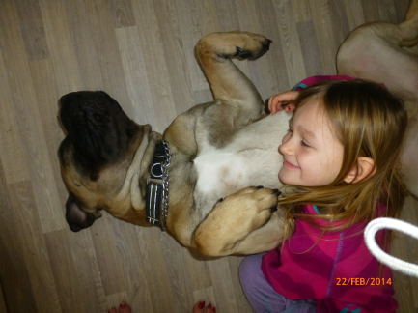
At Christmas 2014 Tiina wrote a 5 pages long letter about what was wrong in the papers of the CPU about quotations of Tiina in connection with the Endringspatruljen. Quotations have been twisted around and turned into lies. This 5 page long letter is still possible to get if needed.

Note: Endringspatruljen and Angel (See chapter „Angel“)
17.05.14 – 24.05.14
Holiday in Turkey
Tiina Latinen was looking for the horses two times a day. From the 18.05.14 the neighbours already startet to get agressive to Tiina and they already found out at which times Tiina is at Helenas property.
Evidental sms (still kept on Helenas phone) between Tiina and Helena show, that in this period the fences of the horse area were opened (three out of four stripes layed on the ground and the horses have disappeared). The neighbours said to Tiina that she should go to a veternarian because they saw that the horses ate poisioned plants. There are no poisioned plants around the area of Helenas property. Tiina got a phone call from police that Helenas horses are feeding on the fields oft he neighbour. (21.05.14)
Tiina wrote in an other sms that Helenas dog Mir started to change. He got scared and started to shiver. He seemed totaly terrified as something happened to him. Mir had to be put down because he got scarred of people due to the fact that somebody did harm on him.

Tiina also said the horses have changed their behaviour. They seemed to be more nervous and stressed. (21.05.14)

Without letting Tiina know the pony of Angel has disappeared. Tiina could not find the pony anywhere. (24.05.14). She checked the fences at 22.00 h the day before (23.05.14). While Helena came back with Angel a neighbour woman (Family name: BOYE) called Helena that she is having the pony at her place. She bought the pony over to Helenas place and used rude words, so that Angel went inside the house.
Tiina and her boy friend Erik went to the police in Arendal to make a report. They were treated very bad by the police (Tiina and Erik were shocked about that experience – Tiina said she never felt more like shit than in that moment. She felt worthless. She was talked to like beeing an idiot from another world) there and beside that they haven’t been alloud to talk to the lokal policeman in Froland named Walter Lie.
Note: A policeman in Arendal said to Tiina and Erik, that the police can not do something because there are no witnesses and the property and the horses are not belonging to Tiina and Erik.
Note: Walter Lie was the only offical person of Froland komune since 2011 who talked to Helena.
Note: On the 20.05.14 Tiina wrote in an sms to Helena that she never would dare to live there. And she asked wheather they will ever stop there deeds.
After the holiday trip to Turkey Helena discovered that her horses have had bad injuries. Naabel has got strangling marks on her neck. Her fur showed signs of hagel shooting, maybe done with small shot. Black Beauty had been beaten (maybe with tools) due to swallen kneens, swallen eyes and on different other parts oft he body.That happened several times. Also on Black Beautys fur Helena found a big long wound on the chest, which could have been done by a knife. (Evidental photos are existing – 6 of them are placed below. Also videos are existing).
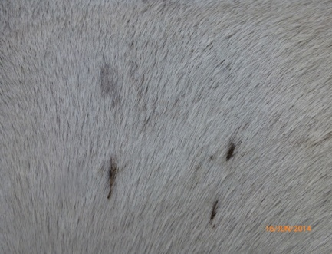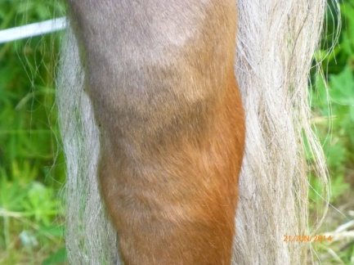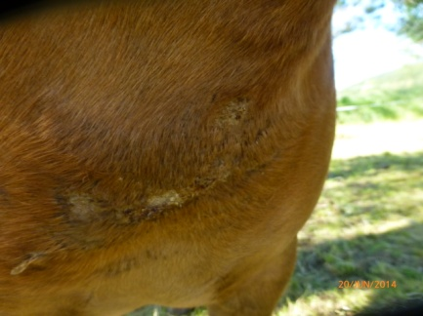
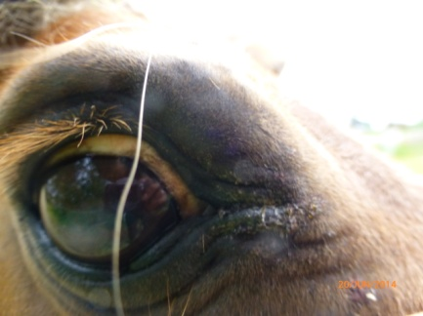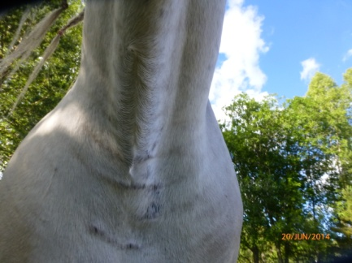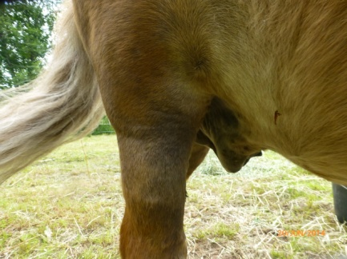
Note: The photos have been showed to a german policeman (Uwe WEGNER) how is owning a horse stable for years now. He declared that all the hurtings could not have been done by the horses itself or by any other natural causes. Somebody has hurt the horses by pure will! He thinks that the big wound on Black Beautys chest could possible also be etched in. The swallen wonds could be made by using something like a hammer.
A possible report will be writen by a independant vitenarian from Germany.

26.05.14 – 04.06.14

In this period of time Uwe Schmidt from Germany visited Helena and Angel on their property. They know each other since 18 years and have been already a couple in the beginning for approximately one year.
This time on Helenas birthday (02.06.14) they both decided to be engaged with each other.

On the 26.05.14 Uwe was introduced to a woman (Family name is FRIVOLD) who is living 10 minutes away from Helenas house. On the way to that woman Helena was attacked verbaly by a young woman in front of a house on the right side of Jomåsveien in the direction to Froland centrum. The woman was shouting at Helena and did not notice that she was trampling down her own baby laying in front of her feet. Her family name is ANDERSON.
Mrs. FRIVOLD reported that the same neighbours who made such problems for Helena attacked herself and her daughter and her animals in the past. That lasts for 20 years. She showed a hole in her house wall which was made by shooting with a rifle.
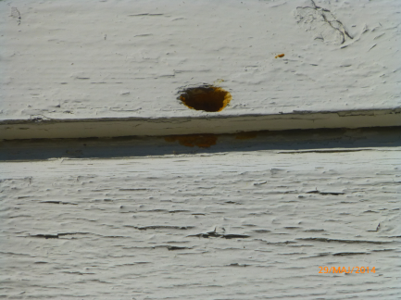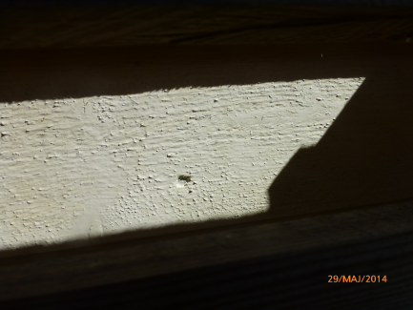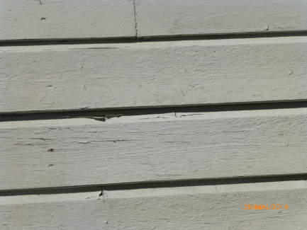
More shots have been damaged the house on terasse wall. Many times when she left her house things have been sabotaged outside the house. Her dog – a german long hair shapard – was burnt by those people (She thinks it has been done by the father of Glenn Roge ANDERSEN. Both are neighbours of Helena on the left side of her property). Cats have been shot by salong guns and one cat was fixed in a strange position by a rope. That cat was also dead. She had to sell her horses due to that animal cruelty. One time a member of the ANDERSON Family steped into her house and held a gun to her head for approximately 20 minutes. Personally she moved away for 1,5 years. She is still suffering to seroius health problems. Her daughter Alexandra is in therapy.
Mrs. FRIVOLD also did not get help from police and Froland komune.
17.06.14:
Helena saw her horses laying down on the ground on her property (Video). They were breathing only very slowly and very slightly.
The drinking water in the bathtub was red. Helena called the lokal policeman Walther LIE and he told her to smell on the red stuff in the water.
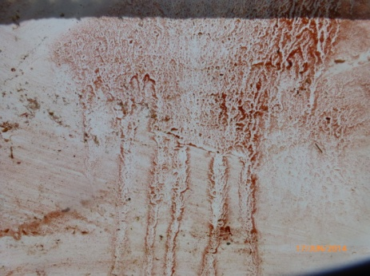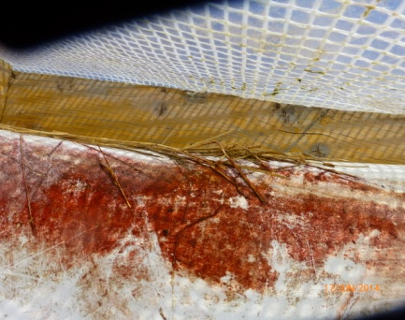
Afterwards Helena got sick. Helena felt dizzy, felt like puking and like having too much beer inside, pricking in the hands, numb arms and very tired. Her fiance Uwe called her early afternoon without having an appointment for that: He said she sounded like totally drunk and she was not able to answer questions in a row. After the third question came the answer fort he first question.

In the evening Helena started to bleed out of her vagina. There was also blood in her urine.
There were big puddles of blood on the bench in the kitchen for example (Photos).
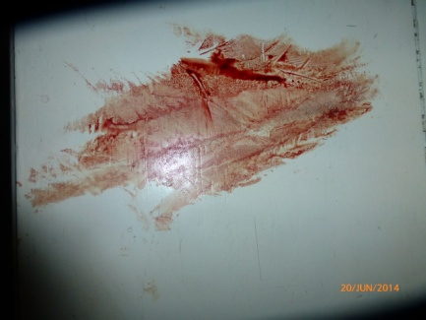

18.06.14
Helena visited Dr. Martin SKOV. He denied to help her and sent her home. Helena explained about her wounds and about the horses. He send her home with the advice to drink more water. He was very nervous and stressed.
Ingebjørg (CPU) was also at the doctors place.
In the paper of CPU stoud already that Helena should be lock up in a mental hospital. They wrote that this was already standing in the papers of Endringspatruljen.
It was hidden later on why Helena was at the doctors place.

20.06.14
Anette ABUSLAND (Wife of Glenn Roger ANDERSEN – Neighbours on the left side of Helenas house – and teacher in the school of Angel in Froland – opposite classroom) went personally to the Endingspatruljen and said that she is afraid that Helena has given „RAT POISON“ to her daughter Angel.
This is only written on own journal of CPU and not given out to lawyers.
But this journal is in Helenas hand.
Due to this connection see the facts concernig the „kakao incident“ under the topic „Angel“!!!

21.06.14
Helena discovered that the fur of Black Beauty looked not normal. Helena pointed out that a powder was massaged into the fur. Helena touched the fur with the fingers of both hands and she saw that a huge amount of that powder has been used. Helena got red powder under her fingernails although the fur looks a bit silver white.
Thereby the mentioned policeman Uwe WEGNER declared once again that natural causes as reasons fort hat can be exluded.
After a short while Helena felt very sick again from breathing in the substance of the fur.

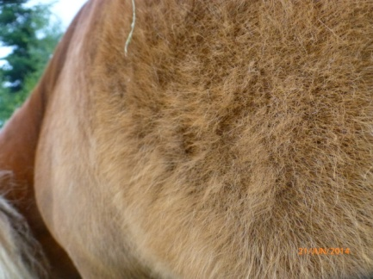
Helena called the ambulance and was brought into the emergency station of „Sykehuset Arendal“. Helena felt the same symptoms again like on the 17.06.14 – but even stronger.

Helena has still red powder under her fingernails. She asked in the hospital to collect it. But they refused to sample it. And also refused to test what it was.

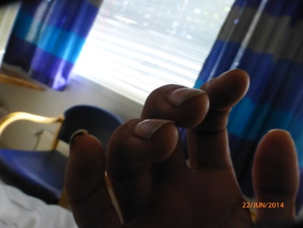
Helena showed the video of the horses laying down on her property to a female doctor. The doctor reacted very strong on that video and afterwards she was not seen again.
Helena called Uwe out of the hospital and Uwe spoke to a female doctor. The female doctor asked him if he observed changes in Helenas behavior during the last time. Uwe just told her about what happened on the 17.06.14.
Helena has to take a urine test. Two cups were full of blood and the doctors said „It looks good“.
Helena asked Uwe to find out in internet what the red stuff in the drinking water of the horses might have been.
In the hospital papers it was mentioned that Helena was brought to a mental section of the hospital and not to a normal emergency station.
Why checked a doctor there every „open part“ of Helenas body? Helena experienced a terrible and emberassing „doctor check up“.

22.06.14
Helena wanted to leave the hospital by free will. Seemingly nobody wants to help Helena with her questions and suggestions. She took a taxi to the lokal gas station, picked up her car and drove home.
When Helena came back from Hospital she discovered that Naabel has got the same strangling marks on the lower part of both frontlegs than she got on her neck before. Helena declares that this marks could have already been there before. She was not sure.
23.06.14
Helena tried to get a blood test at the hospital in Kristiansand. They said it is possible to take a blood test but it supposed to be made in the hospital in Arendal because Helena lived in the fylke of Aust- Agder.
Helena called the hospital in Arendal and they asked her to come over. When Helena reached the parking place of that hospital she got a phone call from that hospital. In a strange tone they refused to help Helena with a blood test. They said further on that Helena has to go back to the doctor house of Froland Komune.
There was a female doctor (Name HOGGANVIK – working for Froland komune) now and she showed Helena papers with a report of the hospital in Arendal. The papers spoke of wrong diagnosis (Bi-Polaris, Identity Problems, Suicide Tries since the age of 7). Helena got scarred because more things haven’t been right: Phonecall between a female doctor and Uwe (The paper says Uwe has said that there has been no changes in the behavior of Helena within the last days – see therefor the 21.06.14). Helena felt that they made strange investigations and tests at the hospital in Arendal which seems not fitting to the currant health problems of her.
Helena asked the doctor if she could read the paper by her own. Then Helena decided to run away with the papers because she felt misunderstood and Helena had the understanding that these things have been sabotaged.
Note: The CPU were talking on the phone with that female Dr. HOGGANVIK (See the papers from CPU – Page Nr. 38). She said without any reason that Helena should be inlocked into a mental hospital against her will. So far they have not manage to reach Helena. She has been in contact with the police to make sure that they arrest Helena and bring her to the mental hospital. To make it sure once again: Helena left Norway this time to go to Germay just to get a blood test there with support of Uwe, because all the doctors in Froland, Vennesla and Arendal refused to do that.
24.06.2014-08.07.2014

Helena visited Uwe in Germany. One reason was to take a blood test. Before her departure the police wanted to arrest Helena and to bring her forcefully into a mental Hospital. Walter LIE told the father of Helena that she can leave the country in peace. Seemingly he was not informed about what is going on.

Note: At the 24.06.14 (and also the day before – 23.06.14) Helenas father was called very often by police and by Dr. HOGGANVIK. They wanted him to bring Helena directly into a police station.

At the airport of Oslo (After the first part of the trip) Helena recieved a phone call from Janne POLLE of CPU. She asked Helena if she has still the red stuff under her fingernails…
During her staying people from a so called „Foodprotection“ called Helena. Helena sent a permission to her brother Øyvind and a girlfriend called Najmi that says that they are allowed to take responsibility of her dogs. In that moment when they supposed to pick up the dogs two men appeared and they pretended to be from an organisation called „Foodprotection“. Without giving further informations they took all the dogs away and brought them to a place unknown.
Helena got afterwards a few phonecalls from several people who pretended to be members oft he „Footprotection“. They told Helena that she has to pay 200 NKR per dog per day as long as she would not pick them up.
On the 10th of July Helena picked the dogs up. She was companied by Uwe and Bert (The father of Angel). Helena had to go to a place called „Josephsens Bil Berging“ in Stoa/Arendal. The contact person from the „Footprotection“ did not want to give out the adress of the place where she has to get back her dogs until she would be in Kristiansand.
When Helena got the adress and arived there a few men were present there. They refused to give us there names and behaved were mystical and rude.
Then Helena wanted to see the dogs and asked if they are having a certificate to keep hold of dogs.
They did not want to come along with papers and they denied Helena to see her dogs.
Although they said they are in charge of many dogs no animal sound was heard there. Suddenly Helena, Uwe and Bert had to leave the hall and like the door of a garage the place was closed. Without further instructions they have to wait there.
After 45 minutes the door was opened again and Helena, Uwe and Bert saw cages with the dogs inside (11 dogs). In the hall suddenly a new man was present.
It seems that the dogs have not been there before, they have been brought there. To the surprise of Helena suddenly she did not have to pay one single Cent for the stay off he dogs. Helena did not have to show her passport to identify her self and also she got no papers from one oft he people at that place.
The owner of that place arrived and did not want to speak English. He said to Helena in a very ironic way: „Take good care of your health.“
Concernig the threatening with the huge amount of money for the dogs seemingly somebody wanted Helena to leave Germany to be back in Norway.

Angel:
Angel had been frozen out by the children in the neighbourhood. That started in may 2013 when the neighbours moved into their new home. Angel constantly asked those childeren to play with her, but the parents of the children told Angel things like that she is smeling like horses and that they don’t have space inside their houses for Angel. They sent her home.
Angel has to sit in the scoolbus by her own because the children said they are not allowed by their parents to sit beside her. Most of the times she has to use another bus stop than the other ones.
The children of the house on the right side of Helena said to Angel that their mother (Maria ANDERSEN – HEIA) pointed out the she knows the police and the police will put Helena into prison so that Angel has to stay alone without her mother.
Note: Maria ANDERSEN is friend with Ove GUNDERSON who is part of in the leadership of Froland kommune-krf politician leader,vara major,and sits in the kommune styret. and he was a police officer in Froland and Arendal.
Helena got help from FAU (Tel.: 92023856) and the school hired an assistant who supposed to drive together with Angel in the bus and be there for her in the breakes. In the beginning this assistant did not show up and after Helena talked to FRU again this assistant entered the bus several stations after Angel got in. After a while this assistant started to park her car at the neighbour houses.
Helena wanted to find out the name oft he assistant but that was denied by the scool. Helena asked again and again because she wanted to know which person is there for Angel. This person never introduced herself to Helena. Afterwards the school told Helena that the name oft he assistant is Anette BJELLAND. But Helena did not find something about her.
Angel started to visit the school in Froland in summer 2013. After a few weeks Angel came home and had a breakdown. She was crying and started to be afraid to go to school. She told her mother Helena that she got beaten with fist in the belly and on her back by the toughest boy in the class. His name is SIGMUND. She was slamed to the ground and her classmates declared her as a „slave“ to a girl in the class. Angel has to give food and clothes to that girl. Angel has to bring money to the school and toys to „buy friends“.
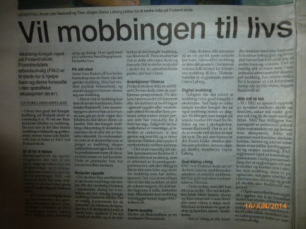
An internet link which leads to other commands of parents concerning bullying and violence among students at Froland Scholl will be attached soon (The link is available at The „Frolendingen Face Book Page). Aslo then it is obvious that also other parents did not get help from the school or komune in their cases.
Froland School and the kommune tried rather to cover up these cases.

Note: The school in Froland is known for the fact to cover up things (Violence and so on…) so that several parents took their children out of that school. One oft he teachers at this school is Anette ABUSLAND.
On the 22.06.14 the CPU decide to picked up Angel from the place of Tiina (The daughter of Tiina named Aila was a class mate and friend to Angel). Angel was at this time at the place of Tiinas mother together with Aila. In the CPU papers stands that Heidi KONNESTAD from Endringspatruljen picked up Angel and brought her to Wenche and Harald LUNDEN. They are the people who took care of Angel since she was 2 years. They took her for one weekend per month.
Exactly that Heidi KONNESTAD interviewed Angel at school (06.06.14). The Endringspatruljen called that interview „Liveform interview“ (It is printed in the CPU papers). There were no witnesses to that interview and it was not filmed or recorded.
Before that interview a not identified teacher came and gave a cup of kakao to Angel. Directly afterwards Angel started to feel sick. She informed Heidi that she felt sick. She felt like puking, she felt tired and she felt like having stripes in her head. She started to open up cupboards in her mind to get out good and bad things. She pointed with her finger to the kakao and told Heidi that this kakao made her sick, which she nearly had drunk out. During this interview Angel informed Heidi about her situation with the children of the neighbourhood. After the interview Heidi told Angel not to speak with her mother Helena about that interview. Angel came home and felt still very sick. Helena asked about the interview (In advance Helena told Angel to be open and honest in this interview). Angel denied to talk with Helena about the interview and she declared that Heidi permitted it.
Note: From that time Angel felt sick and like puking very often when she came back from school. Helena is afraid that something was put into the kakao.

Note: Nearly every time when Helena and Angel went out with the pony of Angel the neighbours came with their cars and drove by very quick and tight and very fast. (Four wheelers – Fotos are existing).
Post B:
From 12.07.14 – 22.07.14
Helena was forcefully put to medication (Zyprexa was the offical version). Helena got huge side effects and asked for stopping the medication. Helena felt very dizzy, very often just staring at walls. She described that state of constituation as being „like a zombie“. Helena forgot a lot of things at that time and she could not concentrate on things.
Helena was a victim to a form of chemical lobotomation just to make her „shut up“ and to give up the case.
Seemingly it was requested that Helena should also stop her documentation about political and illigal and corrupted incidents by Froland komune and her neighbourhood.
All the notes Helena made on her facebook account concerning the mentioned activities were erased from somebody outside while she was at Post B.
Helena did not have her lap top with her at that period of time.
Helena was threatened to not write lyrics about the whole case on the next album (It was a man from Fylkeskommune).
They declared the stay of Helena for all the days as a „forcefully observation“.
The people at Post B told Uwe that Helena did want that he gets any information about her situation. Helena declares that she never said something like this. The people at Post B told Helena everything would be easier for her if she would not be with Uwe anymore (It was the tall man with the black hair). The people at Post B knew that Uwe is a policeman.
Helena says the (false) medication (For false diagnosis: There among Bi-Polarity again) was used to make her shut up and lay back (Political reasons - Due the discovered corruption and dokumented inhabilety and illigal deeds concerning the building of the houses and the road in Helenas neighbourhood).
The doctor in Post B answered to Helena after she asked him where she can make a complain about the treatment in Post B: „If you still want to fight you will get a forcefully medication“. He threatened Helena to use the diagnosis of scizophrenia.
A female employee of an outstanding department said to Helena: „You know what you have to do for not to end back here.“
Another person of that department told Helena that the side effects she suffered so much from have been so strong because she should not have had that medication.

Note: In the papers of Post B stands – in opposite of what was reallity – that Helena showed a good reaction on the medication. A medication she never should have had and did not needed.
After leaving Post B Helena was forced (verbaly threatened) to take the medication further on for three month.

Personal notes:
In late summer 2014 Helenas brother Øyvind was at her property. There appeared a man who introduced himself as a neighbour but the describtion Øyvind gave did not suite to one oft he neighbours. This man said: „It is good that Helena is not here because we want her to move away“.
Further on Øyvind declared that he has been at Helenas place two times. Both times the neighbours were hiding in the bushes on the right side and watched every step he did.
Very often Helena heard shootings from the right side of her neigbourhood. Very often it sounds like amunitions hits stones. Every time than the horses started to run.
The concil of the komune (Formannskapet) has alsways been built up with the same members. Alsways the same group decides in the cases of Helena (It can be proofed in internet on the komune webside).
It is not allowed that the same council members meet about more times in the same case.

The list of the involved members:
Sigmund Pedersen (Major, he represents SP)
Ove Gundersen (Varaurdfører, he represents KFR)
Mari Mykland (Member, she represents SP)
Tove Nilsen (Varamedlem, she represents AP, Vidar Bjørkli)
Ingunn Fjærbu Roppestad (Member, she represents KRF)
Oddvar Østreim (Member, he represents FRP)
Aage Nystøl (Member, he represents H)

The mentioned people can be found on the friend list of the neighbours on facebook. Due to this fact these people are prejudiced.
They never wanted to talk to Helena when she was searching for their contact. They sent Helena out oft he komune building.
It is not allowed to have folkevalgter medlemmer in that council (This fact was found out by a jounalist – name and phone number is available).

The leardeship of Froland komune let the neighbours get away with their illigal work and support them and helped them with illigal decisions.
The leadership of Froland komune hired an assistent for Angel. And this assistent did not write the truth in the logs.
The leadership of Froland komune hired Endringspatruljen especially to suppot the neighbours claims instead of helping a single mother with her child.

In March 2015 Uwe sent an E-Mail to Ingebjørg from CPU with a few questions. Helena requested the answers to be send on Uwe’s account or on the police account. There came no answer and Ingebjørg told Helena that she sent the answer on both accounts but after 3 (!) days she got a reply that the message did not get through. Helena wanted to know who gave the kakao to Angel (name) and if the case should go over to Vennesla (The currant Adress of Helena and Angel from 2014 on) now. Helena also wanted to have the full name oft hat assistant.
Ingebjørg said first that the answers are to sesible for to sent them on an E-Mail account but afterwards she sent an answer to Helena without answering the questions.

On Wednesday the 11.03.15 Helena and Ingebjørg visited the new foster parents of Angel. Although she was there two times before it was hard for her to find the way to the house. The house is unfinished inside – especially the room of Angel. The woman (mother of two girls in the age of 14 and 16) asked for a talk from „mother to mother“ after a while. Ingebjørg agreed first but arrived after a few minutes she came in between the conversation. In that conversation the woman asked Helena, why everything is so full of secrets. She revealed to Helena that she did not see a picture of Angel so far and if Helena has a picture. Helena showed her pictures of Angel on her mobile phone.
On the way back (Helena was picked up by Ingebjørg in her car) Ingebjørg asked Helena about the new Imperia album, tour plans and if the lyrics are already finished (!!!). She was exactly informed about the concert plans in July 2014.
Ingebjørg said further that it is already confirmed that Angel will move over to this place of that people (How can that be when they have not met so far)!
The man in that relationship of the foster people did not say any word. The woman said after she had that two girls with another man Angel should be something like the daughter of the man now because he has no children by his own.
This couple is not married!
Is the whole situation based on a hurry just to be finished before the next court date?
The woman is facebook friend with Andersen, Gunarsen and Petersen from Froland and polititians who are involved into the illiegal building case.
She told Helena that she is not able to handle e-mails and would have no clue about computers.

Rita ANDERSON (Family of the neighbours on both sides of Helenas house) sent false claims (Themes are well known from former false claims) to CPU. She signed that down writen things with her name.

Foto compare between Helena and Angel before the 17.06.14 and afterwards:

Before:middel and end of may
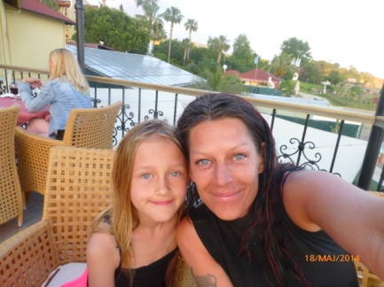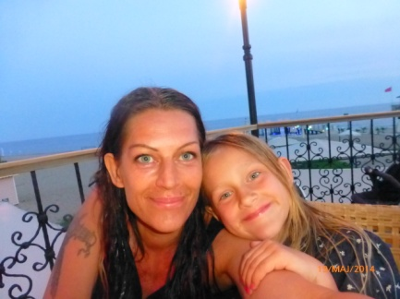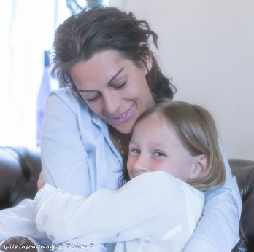
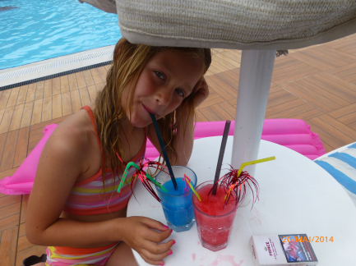

After:11 july 2014

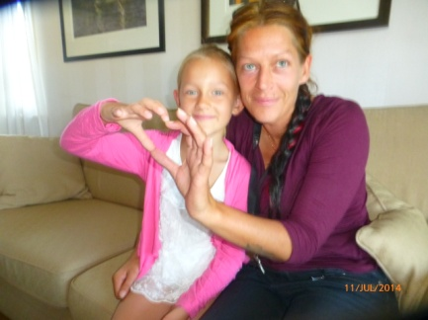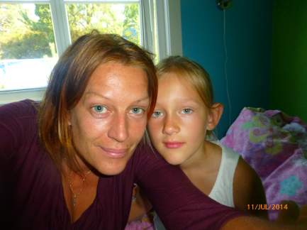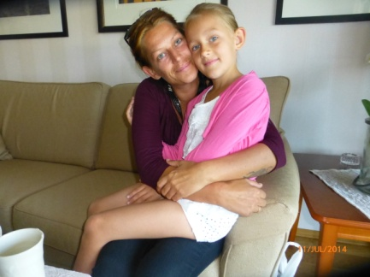

List of neighbour names and family members who can be found back in the concern messages to the CPU:

Neighbours on the right side:

Hege Veronica Andersen
Ken Rune Blankenberg
Maria Andersen Heia
Kjetil Heia

Neighbours on the left side:

Anette Abusland
Glenn Roger Andersen, the parent of Hege Veronica Andersen .

The parents of Glenn Roger Andersen (Names unknown)

Andreas Stien Andersen

Living place Froland:

Rita Andersen

Cathrine Hornbech Andersen

This file is still under construction and not finished so far!
This file is made up to present a better inside view to the awful things that happened to Helena and her daughter and the animals since the year 2011 by the neighbours and froland kommune. But than especially the documented things happend in may-june and july 2014 which is called to be an -acute psykose- of Helena…
Summary:

Due to the incidents documented in this file Helena and Angel lost everything they had.
They suffered to physical interventions and they had to give up their life dream.
They were forced to leave their home and property.
Due to conspiracy connections and innhability on political levels in the end Helena and Angel have been seperated.
With the result that Froland kommune has now the custody of Angel.
Helena asked for help several times from different people in the CPU and Froland kommune and the police since 2011 cause of the unbearabel situation they were in and they never got helped in any way.
That is why Helena started to document the behaviour of the neighbours on her facebook page.
Just based on the hope for help.

Due to the real serious experiences of Helena she is absolut unsecure how to deal with all the cover ups of the facts which definately happened.
Even if Helena has to live with the occured cover ups to get Angel back, she still feels all the revealed facts should be passed over into confidential hands of an indepandant lawyer…

After talking with another victim of political missuse of psychiatrical compulsion and force medical treatment on the phone, her name is Synnøve Fjellbakk Taftø, it was obvious to find similar connections to Helenas destiny.
To mention some examples as there are the same false diagnoses of bipolares written on her which she never suffered to.
She also described her reaction on the forced medical treatment like feeling like a zombie, living in apathy, the loss of creativity and personality changes.

She declared that she recovered a bit from the effects after half a year but creativity was absolutly lost and had not returned so far.
She was never the same again…
Still she is having problems while concentrating on things and she is suffering to a lack of rememberance.

Helena searched for other people with similar histories to talk to and to find a kind of exchanging experiences.

At least Helena tries to make the best out of the currant situation.
Under the mentioned extreme circumstances Helena has done the best she could to keep her daughter out of the horrible incidents.
It was even more difficult due to Helenas status as a single mother without any network around her and family members near by.
She is still hoping for beeing reunited with her daughter again, based on stable life circumstances away from Froland kommune and all involved circumstances.
Helena sold her house in Froland in between.
In the future one of the most important connections should be the main term in the focus:
The wishes of a child and a mother to be reunited again!
The most impressiv example for the natural and pure character of love!
A symbiose which should be respected and protected and not destroyed!
Especially in the case of Helena and Angel!

Future plans:

It is the wish of Helena and Uwe to live together with Angel as a family in Norway.
Uwe has the aim to leave Germany to get a work in Norway and to learn the Norwegian language.

Declaration:

This file should be handled confidential.
The sensible contend should be handled in a safe way with regard on the backround.

Additional informations:

During his stays in Norway Uwe had a few meetings with his colleauge Walter LIE.
Walter declared that „Jomåsveien“ is known as one of the most important roads used by criminals, especially for drug people and their transports.

Walter declared to Uwe that he underestimated the whole situation and that there have been made many faults by the police.

Around the 19th of June in 2014 Helena left her property for picking up Angel. When Helena passed by the Missions Church in Jomås she saw Glenn Roger Andersen and Frode Karlsen with their cars and two other kids standing there. Frode Karlsen known from the drugscene in froland has a military pick up which Helena has often seen in front of the drughouse in Froland and also in front of the house of Glenn Roger Andersen.
Both men were screaming aggressiv the word „Tater“ after Helena. She could understand it because the window of her car was open.
Before she left her property she checked the horses if they are having a normal temperature by holding her hands to their fur. Since everytime she went away if only tot he shop in froland centrum the horses had new bruses and where totally stressed when she came back.
After Helena saw the two men she turned around shortly after cause she was scared they would hurt the horses again and went back to her house. She has been away from her property fro aproximately 15 minutes.On that way back they where gonne and the cars off the neighber and the drug friend was gonne
As she came back she found the horses totaly sweaty and hard breathing. Naabel had new shout gun wounds (Similar to the included pictures on this file).

Due to the fact that Helena was called „tartar“ and the extreme things like the torture of her animals she started to investigate concerning a possible rightextreme background of the deeds done by the included persons.
She discovered that a newspaper („Frolendingen“) was stoped of being published and a journalist got payed to be silent. In that issue the main report shout have been about a rightextreme group and it’s fylkesleader , who was working in Froland kommune. First he worked for „Technical Etat“ and afterwards as a culture leader at Froland School (During the period when also Angel was at that school and when she was given the kakao were she got sick from ). Following that he returned to the kommune as the leader of „Technical Etat“.
„Technical Etat“ was one of the departments in Froland kommune Helena won against by the fylkesmann several times. The mentioned man also worked together with Hans Jomås, who gave threats to Helena because of a possible documention of his manipulation of the maps in the case.
Attached are two links to give further informations:

http://www.nrk.no/sorlandet/forstar-at-styret-stoppet-avisa-1.7767035

http://www.nrk.no/sorlandet/pst-henlegger-froland-sak-1.8007964

As far as many other things in the case and it‘s hard truth and method it might be even mixed in since it’s given fake diagnoses and things changed around in Helenas doctor journals.
And things like that and that no doctor helped Helena, also things that happened via Matlisynet (Footprotection – managed by the state of Norway) and so on.

A lot of documentations from Helenas Facebook accout (privat section) has been suddenly removed from outside.
On her Facebook page Helena was suddenly „friends“ with people she never had „invited“ to be there or never confirmed to be there.
Helena describes here people from the norwegian government (Sturtingsrepesentanter).
That happened exactly then, whe she was writing about things that happened, things that have been covered up and also criminal intentions.
So seemingly somebody still seems to held track on Helenas documentations via Facebook.

A few questions must be allowed at this certain point:

Who has an interest to remove things from Helenas Facebook page?

Who has an interest to manipulate Helenas Facebook account?

Who has an interest to remove exactly those topics on Helenas Facebook accout which were dealing with sensible facts concerning the case (Incidents which happened between May and July 2014)?

And at least – who has the possibility to do that?

With regard on the whole case and on all the things that have happened it should be clear that involved victims come up with their own and personal ideas about the background of these deeds and their creators!!!

Especialy than when children are a part of this terrible circumstances.

In between Uwe had a meeting with Ove GUNDERSEN in the komune house of Froland.
Uwe confronted Mr. GUNDERSEEN with many facts and discovered by his own that Mr. GUNDERSEN used to declare other facts than before mentioned and proofed in this file.

The conversation ended with the question of Mr. GUNDERSEN if we would go further with that evidences.
Uwe made clear to him to do so.
Mr. GUNDERSENS replied to that: „Be aware that you all will probably not have a peaceful and calm time until the court is over.“

